Lesson 17

1. В Google docs створи 5 тест-кейсів для функціонального тестування сайту <https://automoto.ua/uk/> (5 найбільш пріоритетних тестів). *Посилання на документ додай до ЛМС.*

**Description:** Checking the functionality of the automoto.ua website

**Preconditions:** The user visits the website: https://automoto.ua/uk/ and already has a car for sale ad on the website: Auto.Ria

| **Test Scenario:** | Register on the website "automoto.ua" |  |  |
| --- | --- | --- | --- |
| Step# | Test Data | Step Detalis | Expected Results |
| 1.Positive test-case |  | 1.On the main page of the site, click on the icon "Log in to my ads"  2. Enter your phone number  3. Click the "Continue" button  4. Enter a 4-digit code (which will be sent in an SMS message) in the field Enter code from SMS | "Welcome" |
| **Test Scenario:** | Add an advert |  |  |
| Step# | Test Data | Step Detalis | Expected Results |
| 2.Positive test-case |  | 1. Go to the "My Account" tab  2. Go to the page of your ads on the Auto.Ria website  3.Copy the link to your advert  4. paste the link to your advert in the field "Add advert" on the site "automoto.ua"  5. Click the "Add" button | Your ad has been added |
| **Test Scenario:** | Find ads for cars for sale |  |  |
| Step# | Test Data | Step Detalis | Expected Results |
| 3.Positive test-case | Select in ads BMW , 4 series | 1. On the main page of the site, click on the "All" tab  2. In the "All types of transport" column, select "Passenger cars"  3. In the "Brand" column, select "BMW"  4. In the "Model" box, select "4series"  5. In the "Region" column, select "Poltava"  6. In the "Year from" column, select 2020.  7. In the "Age to" column, select 2020.  8. Click the "Search" button. | Ads found for your search |
| **Test Scenario:** | Find a car dealership |  |  |
| Step# | Test Data | Step Detalis | Expected Results |
| 4.Positive test-case | Choose in a Lexus UX car dealership | 1. On the main page, in the upper right corner, click on the "More" button  2. Select "Car dealership"  3. In the column " All types of transport" select " Cars"  4. In the region column, select Kyiv  5. In the "Brand" column, select "Lexus"  6. In the Model column, select "UX"  7. Click "Search" | Found 1 official car dealerships |
| **Test Scenario:** | Find car insurance quotes |  |  |
| Step# | Test Data | Step Detalis | Expected Results |
| 5.Positive test-case |  | 1. on the main page of the website, in the upper right corner, click "More"  2. Click on "More"  3. Select the item "Insurance"  4.In the column "Vehicle" select "Passenger car" select " up to 1600 cc  5. In the column " Engine size select " up to 1600 cc"  6. In the column "City of registration" select "Poltava, Poltava district, Poltava region.  7. Click on the button "Show results" | Found 55 offers |

2. За допомогою <https://reqbin.com/> протестуйнаступні методи API [Reqres](https://reqres.in/):

* LIST USERS
* SINGLE USER
* CREATE
* UPDATE (PUT)
* UPDATE (PATCH)
* DELETE
* REGISTER - SUCCESSFUL
* LOGIN - SUCCESSFUL

Створи документ, в якому у довільному форматі, але зі скриншотами, опиши знайдені баги. Документ додай до LMS.

* LIST USERS

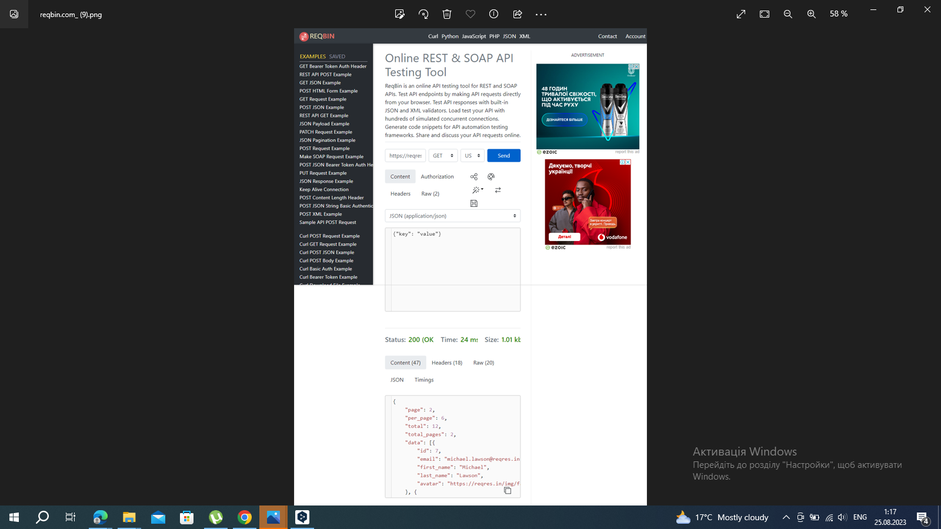

* SINGLE USER

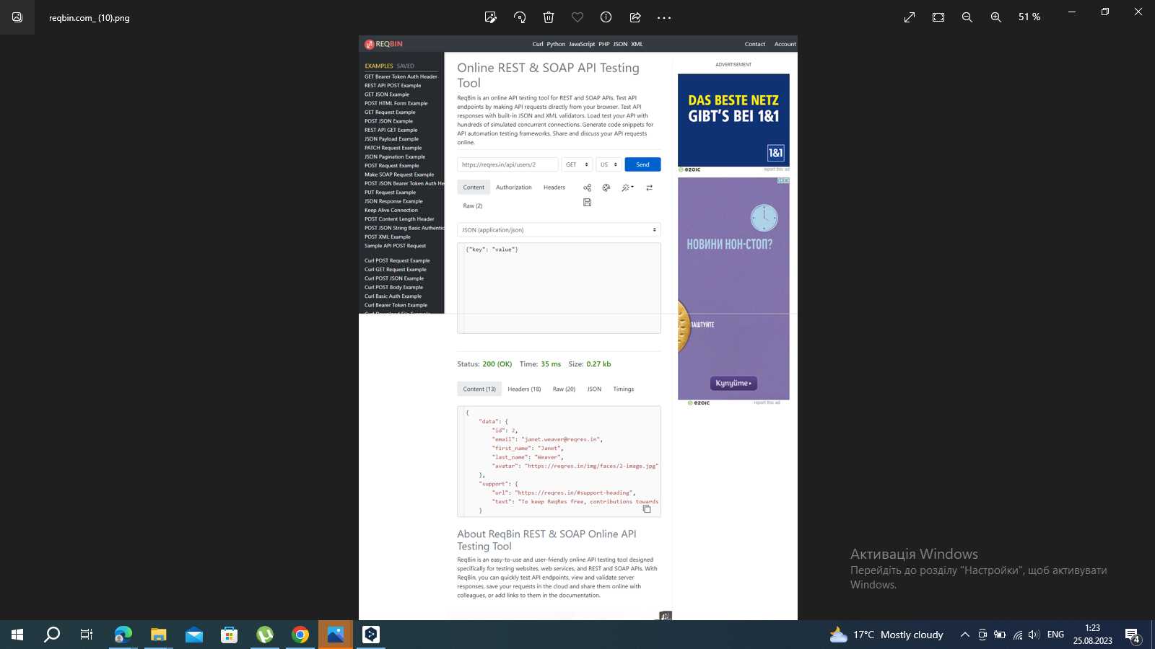

* CREATE

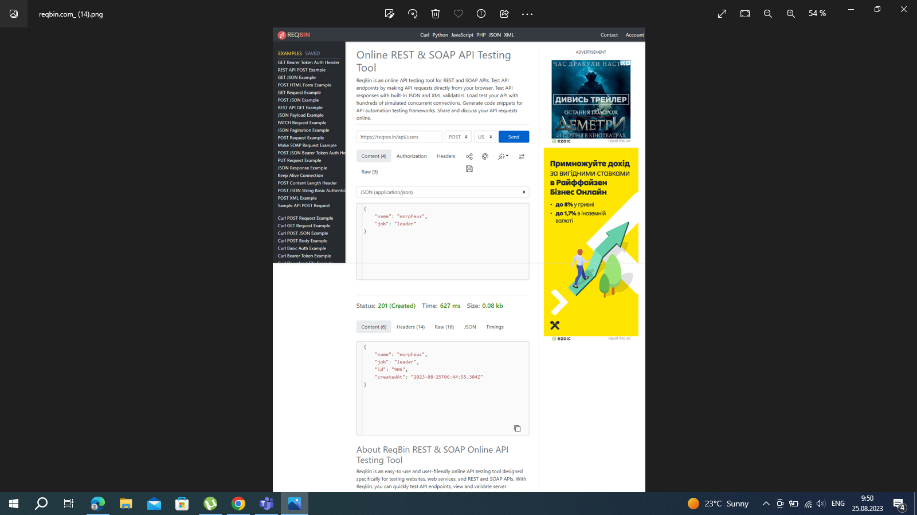

* UPDATE (PUT)

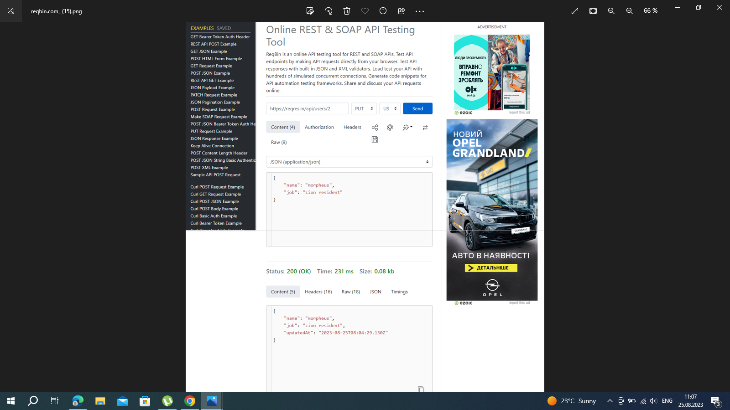

* UPDATE (PATCH)

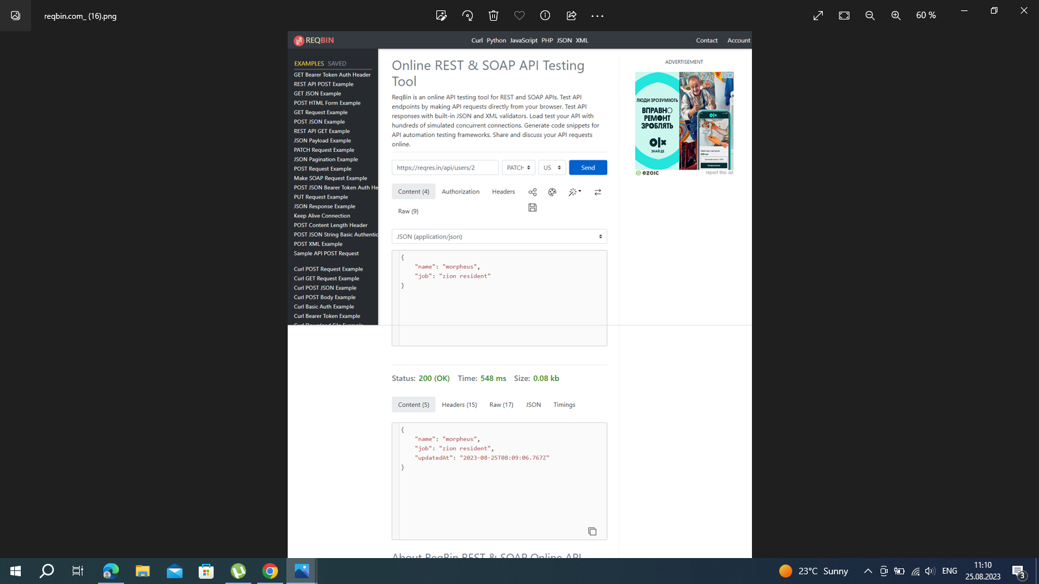

* DELETE

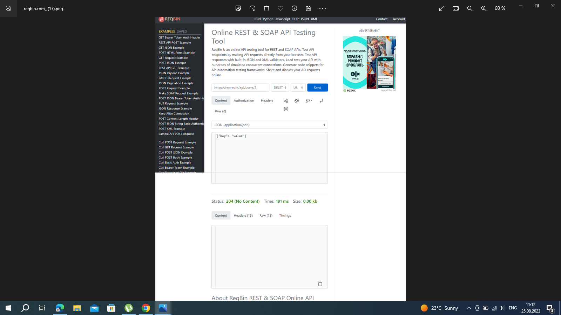

* REGISTER - SUCCESSFUL

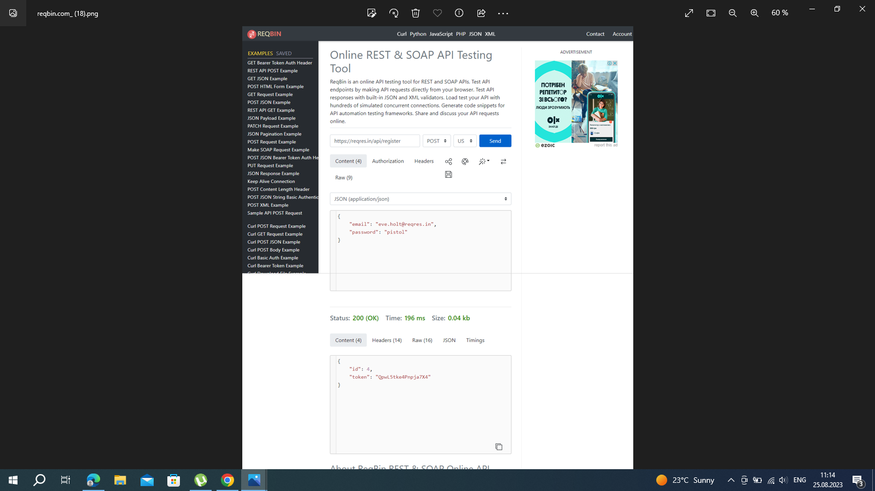

LOGIN - SUCCESSFUL

